January 2019
The making of Ondo®
You may have been frustrated in the past by the fact that such a clever and sophisticated device as a smartphone is not able to measure the temperature. This is quite a challenging thing to do – adding a measuring device to the phone would be relatively easy but this would be measuring the temperature of the phone rather than the ambient temperature of the air around you. There are currently no smartphones on the market that have this ability; instead they rely upon remote weather apps to estimate the temperature – not very accurate when you are indoors!
We set ourselves the difficult design challenge:
How to measure the temperature of air using an iPhone without adding any extra cost and complexity?
The solution was found by utilising an effect from physics and a standard iPhone headset (EarPods) to create a new iPhone application called Ondo.
It is well known in physics that the speed of sound is changed by the temperature of the air that it is travelling in. In fact, this is often considered to be a problem and many acoustic applications need temperature compensating circuits. In Ondo we have used this effect to create an acoustic thermometer – by measuring the speed of a sound travelling through air, it is possible to then calculate the temperature of the air. This gave us a new design challenge:
How to measure the speed of sound in air using an iPhone without adding any extra cost and complexity?
The iPhone is designed for creating and receiving sounds (yes, underneath all the touchscreens, cameras and applications, it is actually a phone!) so this was an easier problem to solve.
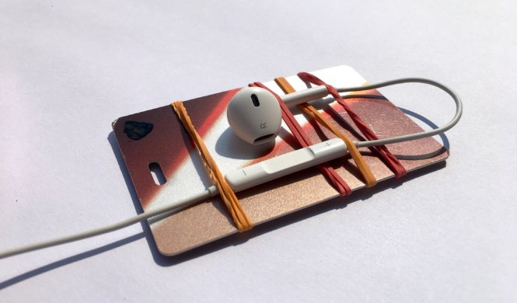
The standard headset provides the necessary speaker (earpiece) and microphone and can easily be positioned away from the phone where the temperature needs to be measured. We created a simple fixture using an old luggage tag and elastic bands to hold the speaker a short, fixed distance from the microphone (see figure 1).
Figure 1: Fixture to position headset earpiece and microphone
Ondo transmits a high frequency sound from the earpiece and measures the time delay for the sound to be received by the microphone very precisely. A high frequency signal was selected to increase the accuracy and has the added benefit of being inaudible to most ears.
The distance between the earpiece and microphone will vary from fixture to fixture. This means that the first time that Ondo runs it must be calibrated using a known temperature. Once calibrated, provided the distance between the earpiece and microphone does not change, the headset can continue to be used as a thermometer.
Educational aid or just for fun….
We think Ondo will make a great educational resource for teaching some of the physics behind sound and sound waves, so we have created a lesson planner to support teachers available on the website.

Simon Barnard
Director, SCB Associates Ltd
simon@ondo.app

Ondo® is a registered UK trademark. UK patent application GB1817969.7

